
2024 - 2025
GROUP 13_FIN350 PROJECT
Optimizing a Stock Trading Strategy for the Tunis Stock Exchange
Family Name | Name | Major/Minor | ID
Lassoued | Malek | FIN/ACC | 13655519
Labidi | Mohamed Aziz | FIN/ACC | 13656304
Ben Attia | Isra | FIN/ACC | 04960548
Arfaoui | Eya | FIN/IT | 14370519

NOTE: If any of the links are broken, you can find the corresponding files in the ZIP archive.
PART 1: CHOICE OF THE STOCKBROKER:
For this project, our group initiated discussions during our first meeting to outline the approach for selecting a stockbroker. This meeting served as the foundation for our decision-making process. During this meeting, we discussed:
- The importance of selecting a stockbroker that adheres to ethical and professional standards.
- Criteria for shortlisting potential stockbrokers.
- An action plan to contact and evaluate multiple brokerage firms.
Details of the meeting: First Meeting Notes
Following the first meeting, our group compiled a list of seven stockbrokers to contact. These brokers were chosen based on their reputation, range of services, and accessibility. The list was prepared in a file that contains details such as:
- Broker name.
- Contact Information: Phone and Address.
- Planned date of visit.
Details of file: List of stockbrokers
After our initial visits, we conducted a second meeting to discuss the outcomes and assess the feedback from the brokers contacted. During this meeting, we narrowed our focus to four companies. This decision was influenced by the fact that MAC SA had already offered the competitive fees we were seeking set at 0.2% that aligned with our project requirements. The outcomes of the visits were summarized in a file that highlights:
- Details of the offerings.
- Feedback for the four companies contacted.
- Key takeaways from our discussions with each broker.
Details of the meeting: Second Meeting Notes
As the ultimate choice of the stockbroker, our group has selected MAC SA (Maison d'Analyse et de Conseil) as the preferred stockbroker due to its established reputation, adherence to professional and ethical standards, and notable success in the Tunisian financial market.
Why MAC SA ?
- Comprehensive Services:
- MAC SA offers a wide range of services, including stock brokerage, market analysis, and portfolio management. These services provide investors with a well-rounded approach to managing their financial needs.
- The firm’s ability to develop tailored investment strategies ensures alignment with clients' specific financial goals and risk profiles.
- Competitive fees:
- MAC SA offered the brokerage fees we were seeking, set at 0.2%. This competitive fee structure aligns with our project’s budget and cost-efficiency goals.
- Ethical Integrity:
- The company prioritizes ethical business practices, including managing conflicts of interest, safeguarding client privacy, and providing clear, unbiased advice.
- These principles ensure a high level of client satisfaction and trust.
- Regulatory Compliance:
- As a fully licensed entity regulated by the Commission du Marché Financier (CMF), MAC SA ensures strict adherence to Tunisian financial regulations, fostering transparency and trust among its clients.
- Reputation and Track Record:
- MAC SA has a longstanding presence in the market, cementing its position as one of Tunisia’s leading stockbrokers.
- It is trusted by both individual and institutional investors, thanks to its in-depth market insights and successful investment strategies.
Attached is a copy of the contract in photo format: Contract Copy

PART 2: CHOICE OF THE 20 STOCKS:
In selecting the 20 stocks that we wanted to focus on in the TSE, we opted for a mix of the top-down and bottom-up approaches. In the first part of the process, we began by studying macroeconomic factors and their effects on various sectors. This allowed us to determine which sectors would present the best investment opportunities. The sectors were chosen based on their potential for growth and resilience in the current economic environment. The specific factors analysed and their implications for each sector are detailed below.
- MACROECONOMIC FACTORS :
- INTEREST RATE :
TN interest rate is 8% on 25/09/2024 (the highest since 2006) and is expected to stay constant for this quarter. In this case certain sectors stand out as attractive investment opportunities due to their ability to perform well in predictable economic conditions. Utilities and consumer staples are popular choices, offering consistent returns and resilience to market volatility as they provide essential goods and services. Healthcare companies also thrive, benefiting from steady demand for medical products and services regardless of economic cycles. Additionally, financials, including banks and insurance companies, may see steady growth, with predictable net interest margins and stable investment income. Technology and industrials also capitalize on stable borrowing costs to drive innovation and expansion.
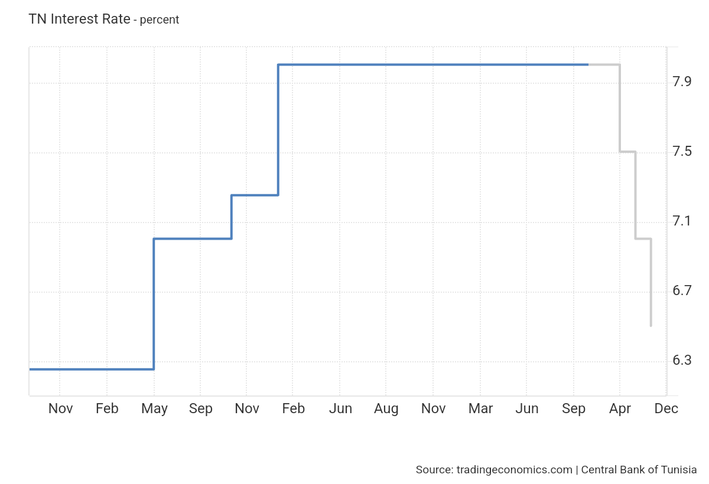

- EXTERNAL DEBT:
External debt decreased in the second quarter of 2024 from 1304241 million TND (Q1) to 1285383 million TND (Q2) this can have similar positive effects on equity investments as stable interest rates. Both factors contribute to economic stability, fostering investor confidence and supporting sectors like financials, real estate, and consumer discretionary.

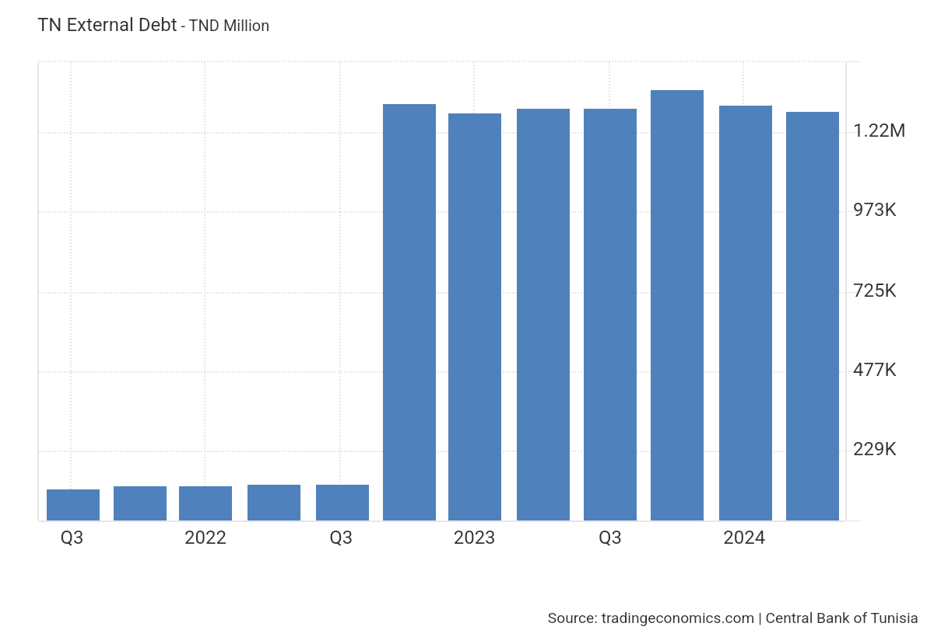
- CURRENCY: 23/10/2024:
The provided exchange rates represent the currencies of Tunisia's main trading partners, reflecting the economic relationships with key markets. These include the Euro (EUR) for significant trade with the European Union, the US Dollar (USD) for global transactions and imports, and the currencies of neighboring North African countries such as the Algerian Dinar (DZD) and Libyan Dinar (LYD).
- 1USD=3.11 TND and is expected to increase to 3.21 in 2025.
Best sectors to invest in:
Export-Oriented Sectors: As the TND weakens against US dollar, Tunisian products become cheaper and more competitive in global markets. Sectors like agriculture (olive oil, dates), textiles, and tourism are likely to benefit from increased demand in countries where the USD is a strong currency.
- 1EURO= 3.36 TND and is expected to decrease in 2025 by 0.01 TND.
Best sectors to invest in:
Manufacturing and Automotive: Companies that import automotive products from European suppliers could benefit from stable import costs, with minimal impact from the Euro's slight decrease.
- 1DZD= 0.023 TND and is expected to stay constant for this quarter.
- 1LYD= 0.64 TND and is expected to stay constant for this quarter.
For both Algeria and Libya, the stable exchange rates with the Tunisian dinar (TND) suggest minimal disruption to sectors relying on trade between Tunisia and these two countries.
Best sectors to invest in:
Agriculture, construction, and consumer goods sectors are likely to maintain steady business, as cross-border trade remains predictable. Additionally, tourism, particularly from the Libyan diaspora in Tunisia, may also remain consistent .
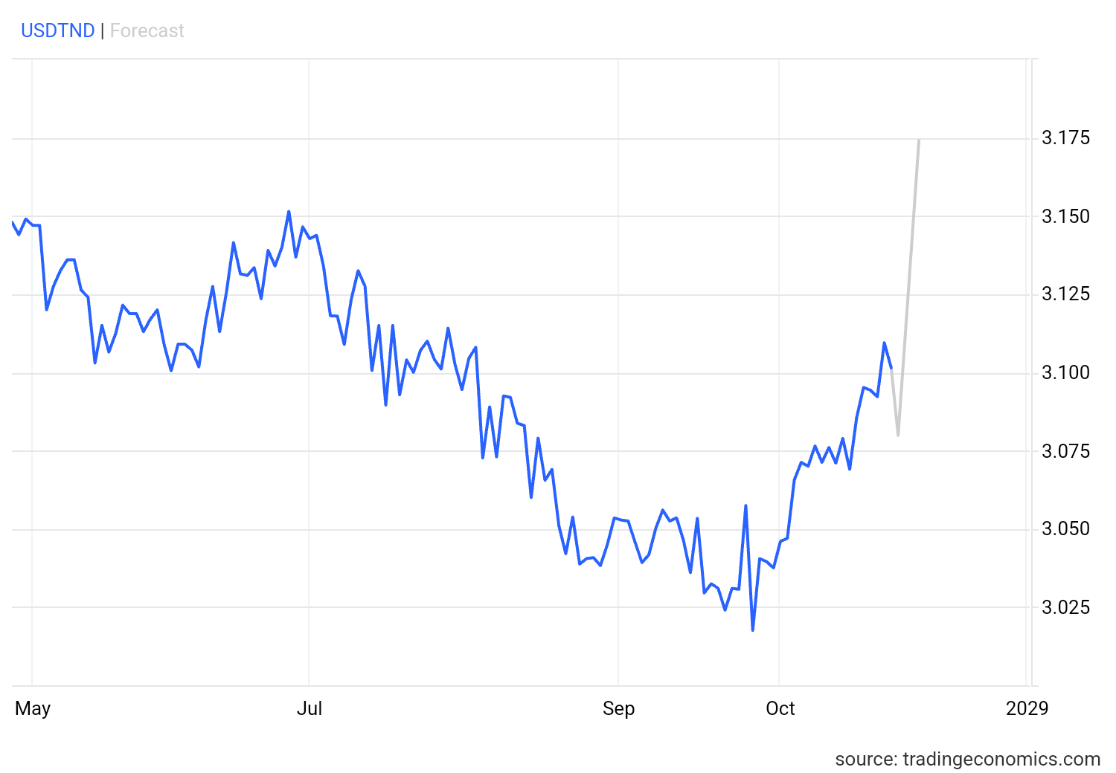
- GROSS DOMESTIC PRODUCT:
The GDP of Tunisia expanded by 0.8% in Q3 2024, after a 0.2% rise in the previous quarter, marking the highest quarter-on-quarter growth in almost 3 years. Additionally, it is expected to be 0.50% by the end of this quarter, according to Trading Economics global macro models and analysts’ expectations.
In this case, sectors like consumer staples (food, beverages, and household products) tend to perform well even in slower economic conditions, as demand for essential goods remains stable. Additionally, industrials related to infrastructure and manufacturing may continue to perform due to ongoing projects and economic activity. For more stability, utilities and financial services can be considered, as these sectors generally experience steady demand and are less impacted by short-term economic fluctuations.

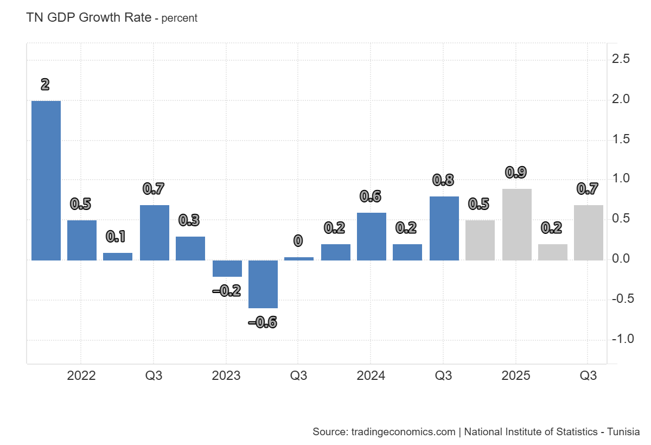

- INFLATION RATE:
Inflation Rate in Tunisia is 6.70% in September 2024 and is expected to be 6.20 percent by the end of the 4th quarter, according to Trading Economics global macro models and analysts’ expectations.
Consumer staples, such as food, beverages, and household products, tend to perform well during inflationary periods as demand for essential goods remains steady. Similarly, the utilities sector, which provides essential services like water, gas, and electricity, is also relatively unaffected by inflation, offering stable returns. Additionally, financials, including banks and insurance companies, may benefit from higher interest rates, which often accompany inflation.
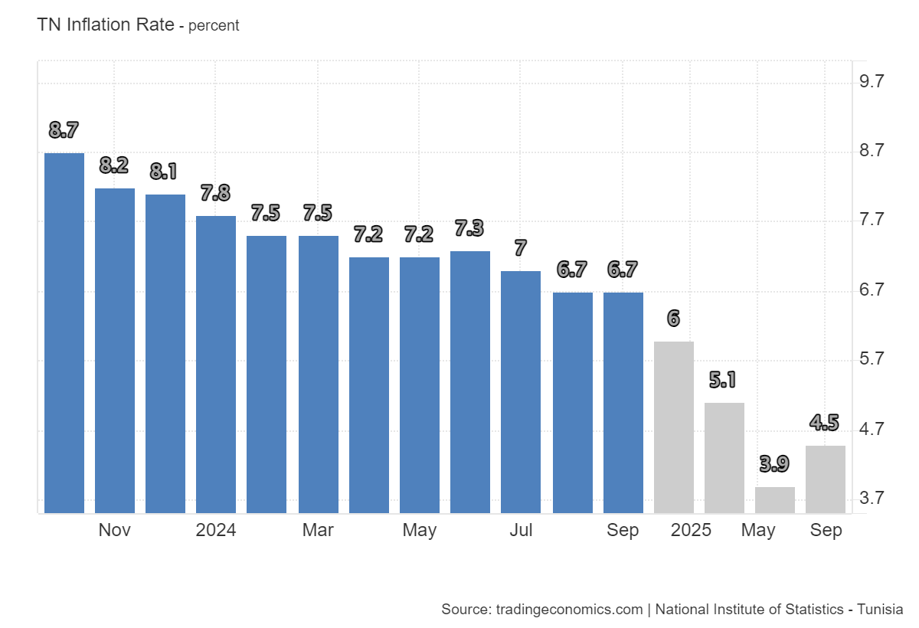
- POLITICAL SITUATION:
- Political Instability: Tunisia’s political instability has made long-term government policies, including environmental projects, unreliable. This increases uncertainty for sectors dependent on government initiatives (like infrastructure or green energy). When selecting sectors, it is better to avoid relying heavily on government-driven sectors that might be affected by political inaction or abrupt policy changes.
- Environmental Policy Weakness: With minimal progress on environmental reforms, sectors like waste management and renewable energy are unlikely to see significant government support in the near future. This may limit the growth potential of companies operating in these sectors unless private investment steps in.
- Consumer Staples and Healthcare: Given the political focus on populism rather than institutional reforms, essential sectors such as consumer staples and healthcare might be more resilient, as they are less dependent on long-term government initiatives and are considered more stable during economic and political uncertainty.

After carefully considering the relevant macroeconomic factors and aligning them with our investment budget, we initially selected 27 stocks from a range of sectors. To enhance the selection process, we focused on identifying competitors within certain sectors. Provided below are the 27 stocks that were chosen based on their performance, growth prospects, and their relevance within their respective sectors:
- Consumer Goods:
- Poulina Group Holding
- Société Frigorifique Et Brasserie
- Land Or
- Société Delice Holding
- Société d’Articles Hygiéniques
- Société Tunisienne des Industries de Pneumatiques SA
- Consumer Services:
- Société Tunisienne des Marchés de Gros SA
- Magasin Général
- Ennakl Automobiles SA
- Smart Tunisie SA
- Automobile Réseau Tunisien Et Service SA
- Industrials :
- Carthage Cement
- Les Ciments De Bizerte
- Société Tunisienne De Verreries
- One Tech Holding
- Manufacture de Panneaux Bois du Sud SA
- Société Tunisienne Industrielle Du Papier Et Du Carton SA
- Société Tunisie Profilés Aluminium
- Financials :
- Arab Tunisian Bank
- Banque De Tunisie
- Banque Nationale Agricole
- Société Tunisienne De Banque
- Assurances Maghrebia Vie SA
- Tunis Re
- El Wifack Leasing
- SPDIT-SICAF
- TUN INVEST – SICAR
- RETURN METRICS COMPUTATION :
In this section, we prepared and processed stock return data for a selection of 27 stocks. The daily stock prices for the past 10 years were sourced through our broker, ensuring comprehensive historical coverage. To facilitate analysis, we calculated the adjusted daily returns, incorporating the effects of corporate actions such as stock splits and dividend payments to reflect the true performance of each stock. Using these adjusted returns, we derived key metrics including the annual expected return and both daily and annualized standard deviation, which provide insights into return variability. We also computed the Sharpe Ratio as a foundational tool for assessing risk-adjusted performance. Additionally, advanced statistical measures such as Value at Risk (VaR), adjusted Sharpe Ratio, kurtosis, and skewness were determined to evaluate the distributional characteristics of returns. These metrics offer a deeper understanding of the risk, return asymmetry, and extreme value tendencies of the stocks.
All data and calculations are organized and documented in an Excel file, which serves as a central reference for this analysis and subsequent sections of the project: Adjusted Returns and Metrics
- FUNDAMENTAL AND RISK ANALYSIS :
To identify the 20 stocks, we employed a combination of fundamental analysis and risk assessment metrics. This methodology ensured that our selection prioritized financial stability and consistent performance while carefully considering exposure to market volatility.
For the fundamental analysis, we evaluated the following key financial ratios:
- Earnings per Share (E/S)
- Profit Margin
- Return on Equity (ROE)
- Change in Revenue
- Current Ratio
- Debt Ratio
- Debt-to-Equity (D/E) Ratio
- Price-to-Earnings (P/E) Ratio
For the risk assessment, we incorporated:
- Beta (to measure each stock's sensitivity to market movements)
- Sharpe Ratio (to ensure returns were appropriately adjusted for risk)
A file containing all the detailed data for the ratios and calculations is attached: companies' financial data
Here’s a refined analysis with a stronger focus on the value each company offers:
- Consumer Goods:
- Poulina Group Holding:
POULA offers remarkable value with a massive profit margin of 93.9% and an ROE of 18.42%, reflecting its dominance in its industry. The company’s exceptional revenue growth of 69.4% signals strong expansion potential, while its low debt-to-equity ratio of 0.14 suggests a prudent approach to financial management. POULA’s beta of 0.17 means it is less sensitive to market movements, providing a secure, low-risk investment. Though the Sharpe ratio is 0.005, POULA’s growth trajectory and low leverage position it as a high-value asset for long-term investors.
Conclusion: POULA’s extraordinary profitability and growth potential offer great value with limited risk exposure
- Société Frigorifique et Brasserie:
SFBT represents one of the most attractive investment opportunities, with an impressive EPS of 1.05, a profit margin of 20.57%, and an outstanding ROE of 21.17%. Its revenue growth of 2.96% and current ratio of 3.3 demonstrate strong liquidity and operational efficiency. With a conservative debt-to-equity ratio of 0.51 and a low debt ratio of 33.63%, SFBT offers a stable financial position. The low beta of 0.25 and exceptional Sharpe ratio of 0.409 highlight its resilience and excellent risk-adjusted returns.
Conclusion: SFBT’s exceptional profitability, solid financial management, and low market sensitivity make it an outstanding value investment.
- Land Or:
LNDR offers significant growth potential with a solid EPS of 0.5, a profit margin of 2.68%, and an impressive revenue increase of 34.31%. The company’s current ratio of 1.41 highlights strong liquidity, while its manageable debt-to-equity ratio of 1.38 indicates a balanced capital structure. With a beta of 0.39, LNDR offers moderate exposure to market fluctuations. The Sharpe ratio 0.005 confirms steady risk-adjusted returns. LNDR’s combination of profitability and growth at a reasonable price makes it a great value investment.
Conclusion: LNDR provides strong value with a solid financial base and promising growth outlook.
- Société Delice Holding:
DH offers strong value with an EPS of 1.78, profit margin of 7.04%, and an impressive ROE of 22.14%. The company’s steady revenue growth of 9.63% and a solid current ratio of 1.79 demonstrate financial stability and liquidity. Its debt-to-equity ratio of 0.61 and debt ratio of 54.21% indicate a well-controlled leverage position. DH’s beta of 0.15 shows minimal market volatility exposure, and although its Sharpe ratio is slightly negative (-0.166), the company’s strong fundamentals still make it an attractive long-term investment.
Conclusion: DH’s strong fundamentals and profitability offer significant value, despite moderate market sensitivity.
- Société d’Articles Hygiéniques:
SAH presents extraordinary value, with an EPS of 64, one of the highest in its sector, demonstrating its ability to generate significant earnings. Its ROE of 11.17% and profit margin of 3.98% highlight solid profitability and operational efficiency. The company’s current ratio of 1.07 ensures it can comfortably manage its short-term liabilities. With a debt-to-equity ratio of 2.38, SAH balances growth with control over financial leverage. The low beta 0.14 coupled with an impressive Sharpe ratio 0.232 demonstrates minimal volatility and excellent risk-adjusted returns.
Conclusion: SAH’s robust earnings, profitability, and low market sensitivity make it an exceptional value investment.
- Société Tunisienne des Industries de Pneumatiques SA :
Although STIP faces challenges in its fundamentals, with negative EPS (-0.37), a profit margin of (-1.14%), and an ROE of (-10.4%), its strengths lie in its risk profile. The company's exceptionally low beta 0.04 indicates almost no market volatility, making it a stable investment during uncertain times. Additionally, its slightly positive Sharpe ratio 0.011 suggests that the company offers better risk-adjusted returns than most in its sector, despite its financial struggles. While its high debt-to-equity ratio 14.5 and weak liquidity current ratio of 0.7 are concerns, STIP’s low beta and stable returns position it as a viable option for risk-averse, short-term investors seeking to prioritize stability over immediate financial performance.
Conclusion: Despite fundamental weaknesses, STIP's low-risk profile makes it a reasonable choice for conservative investors focusing on minimizing volatility.
- Consumer Services:
- Société Tunisienne des Marchés de Gros SA :
MGR stands out with an impressive EPS of 0.58 and an excellent ROE of 22.2%. The company demonstrates stable growth with a revenue increase of 7.2%. MGR also has a low debt-to-equity ratio of 0.18 and a minimal debt ratio of 15.6%, reflecting a strong and healthy financial position. Its Sharpe ratio of 0.484 indicates positive risk-adjusted returns, making MGR a strong investment opportunity with low risk and strong profitability.
- Magasin Général :
SMG faces significant challenges with a negative EPS of (-2.69) and a profit margin of (-3.96%), indicating ongoing struggles with profitability. The company's debt ratio of 111% and low current ratio of 0.67 suggest liquidity and solvency issues. The extremely negative Sharpe ratio of (-0.687) also points to high volatility and poor risk-adjusted returns, positioning SMG as a high-risk investment with weak financial fundamentals.
- Ennakl Automobiles SA:
NAKL presents a positive outlook with an EPS of 1.34 and a profit margin of 5.64%. The company shows strong profitability with a ROE of 18.25% and steady revenue growth of 7.1%. NAKL’s low debt ratio of 45.9% and manageable debt-to-equity ratio of 0.85 reflect solid financial health. The Sharpe ratio of (-0.153), while slightly negative, does not overshadow the company's strong fundamentals and growth, making it an appealing option.
- Smart Tunisie SA :
SMART has an EPS of 1.61, which indicates profitability, but its relatively low profit margin of 4.62% suggests that the company could face challenges in sustaining high returns. While the ROE of 15.7% demonstrates effective equity use, its moderate debt ratio of 49.7% and debt-to-equity ratio of 0.98 raise concerns about financial leverage and potential risks. The current ratio of 1.54 is decent, but the negative Sharpe ratio of (-0.293 ) reflects potential volatility, indicating that SMART may be a less attractive option compared to other companies with stronger financials.
- Automobile Réseau Tunisien Et Service SA :
ARTES is an attractive investment with an EPS of 0.71 and a solid ROE of 22.7%, demonstrating strong profitability and efficient use of equity. The company maintains a stable current ratio of 1.87, indicating good liquidity, and a manageable debt ratio of 34.97%, with a low debt-to-equity ratio of 0.54. Its Sharpe ratio of 0.09 further highlights positive risk-adjusted returns, reinforcing ARTES’s strong fundamentals and growth potential as a favorable choice for investment.
- Industrials:
- Carthage Cement:
CC demonstrates a mix of strengths and challenges. Its EPS of 0.1 and profit margin of 16.39% indicate moderate profitability, while the ROE of 12.07% suggests some efficiency in equity utilization, albeit below sector benchmarks. Revenue growth of 1.01% is positive but modest, and the current ratio of 1.04 points to limited short-term liquidity. However, the company’s debt-to-equity ratio of 2 and debt ratio of 66.5% highlight a significant reliance on debt financing. On the risk side, CC’s low beta 0.216 suggests minimal market volatility, but the Sharpe ratio of (-0.316) indicates that risk-adjusted returns are not currently favorable. While CC offers certain positive aspects, the combination of high leverage and modest financial performance presents considerable challenges for investors.
- Les Ciments De Bizerte :
Fundamentally, SCB’s performance is highly concerning, with negative EPS (-0.61), a profit margin of (-13.81%), and an ROE of (-17%), signaling heavy losses. Its low current ratio 0.27 raises significant liquidity concerns, and its debt metrics, although slightly better than CC, remain risky. From a risk analysis perspective, the beta 0.667 is high, indicating volatility, and the Sharpe ratio
(-0.858) suggests substantial risk without reward.
Conclusion: SCB is not suitable for risk-averse, short-term investors due to its poor fundamentals and high risk profile.
- Société Tunisienne De Verreries :
SOTUVER demonstrates moderately strong fundamentals, with positive EPS 0.16, a healthy profit margin 12.17%, and an ROE of 5.41%. However, its negative revenue growth (-38.8%) and slightly low current ratio 0.74 present areas of concern. On the risk side, its beta 0.166 is low, signaling low market volatility, and the debt-to-equity ratio 1.96 is manageable. The positive Sharpe ratio 0.307 indicates favorable risk-adjusted returns, contributing to a balanced risk profile.
Conclusion: SOTUVER is a reasonable choice for risk-averse, short-term investors due to its balanced fundamentals and low market volatility.
- One Tech Holding :
Fundamentally, OTH is stable, with a strong EPS 0.51, profit margin 3.87%, and an ROE of 9.99%. It shows strong liquidity with a current ratio of 1.99 and manageable leverage, as evidenced by its debt-to-equity ratio 0.77. Risk analysis supports this position, as the beta 0.21 reflects low market volatility, and the positive Sharpe ratio (0.130) indicates favorable risk-adjusted returns, reinforcing its stability.
Conclusion: OTH is a reliable option for risk-averse, short-term investors due to its solid fundamentals and low-risk profile.
- Manufacture de Panneaux Bois du Sud SA :
MPBS shows solid fundamentals, with positive EPS 0.28 a modest profit margin 2.38%, and steady revenue growth 8.17%. Its strong liquidity (current ratio of 1.91 and low debt-to-equity ratio 0.83 ensure financial stability. Risk-wise, the beta 0.3 indicates low market volatility, and the Sharpe ratio 0.172 demonstrates favorable risk-adjusted returns.
Conclusion: MPBS is a good choice for risk-averse, short-term investors due to its solid financial performance and minimal market risk.
- Société Tunisienne Industrielle Du Papier Et Du Carton SA :
STPAP displays strong fundamentals despite minor weaknesses. Its EPS is 0.009 and profit margin 2.46%, indicating marginal profitability. However, the ROE of 3.28% suggests the company is less efficient at generating returns. While revenue growth (-37.89%) is concerning, its current ratio 1.57 signals solid short-term liquidity. The debt ratio 39.8% and debt-to-equity ratio 0.66 are healthy, indicating effective debt management. In terms of risk, STPAP has a beta of 0.069, making it less volatile than the market.
Conclusion: STPAP is a solid investment for risk-averse investors, given its low leverage, positive risk-adjusted returns, and overall financial stability.
- Société Tunisie Profilés Aluminium:
TPR exhibits the strongest fundamentals, with an impressive EPS 0.83, profit margin 14.4%, and ROE 22.9%. Revenue growth 1.1% and a high current ratio 2.27 underline its financial health, while its low debt-to-equity ratio 0.88 ensures stability. Risk analysis shows a low beta 0.189, reflecting minimal volatility, and a positive Sharpe ratio 0.039, indicating strong risk-adjusted returns.
Conclusion: TPR is the most favorable choice for risk-averse, short-term investors due to its excellent fundamentals and low-risk profile.
- Financials:
- Arab Tunisian Bank:
Arab Tunisian Bank is in poor financial condition, with negative EPS (-1.2), a profit margin of -0.02%, and an ROE of -0.03%, indicating consistent losses and no profitability. The company is dangerously overleveraged, with a debt ratio of 91.6% and a debt/equity ratio of 12.53, leaving it highly vulnerable to financial instability. Risk analysis further highlights its poor performance, as a Sharpe ratio of (-0.289) reflects unfavorable risk-adjusted returns. Overall, the bank's fundamental and risk metrics make it a highly unattractive and risky investment choice.
- Banque De Tunisie :
BT demonstrates strong profitability with an EPS of 0.67, ROE of 12.34%, and a profit margin of 24.51%. However, its debt-to-equity ratio 4.69 and debt ratio 82.41% indicate high leverage, making it a riskier investment. Despite a reasonable P/E ratio (7.44/8.7x), its Sharpe ratio (-0.258) suggests poor risk-adjusted returns, making it a less attractive choice for those seeking stability.
- Banque Nationale Agricole :
BNA stands out with robust EPS 3.34, a profit margin of 9.87%, and a solid ROE 10.42%, showcasing strong profitability and shareholder returns. The bank's impressive revenue growth 19.7% signals operational excellence, while its P/E ratio (2.34 vs. sector’s 8.7x) highlights significant undervaluation and upside potential. Furthermore, BNA’s beta 0.298 compared to the sector average (0.54) underscores its lower market volatility, suggesting a more stable investment relative to its peers.
In summary, BNA’s profitability, growth, undervaluation, and low beta make it a compelling investment opportunity.
- Société Tunisienne De Banque :
STB shows some positive signs with a moderate EPS of 0.50 and a profit margin of 3.51%, but it presents considerable risk for a risk-averse investor. The high debt-to-equity ratio 10.06 and debt ratio 88.7% indicate the bank is overleveraged, increasing its vulnerability. Despite 10.80% revenue growth, its Sharpe ratio (-0.483) reveals poor risk-adjusted returns, making STB too risky for conservative investors.
- Assurances Maghrebia Vie SA :
AMV stands out with an EPS of 7.32 and a solid profit margin of 9.24%, reflecting healthy profitability. Its ROE of 16.6% shows a strong return on equity, and the 8.7% revenue growth further strengthens its growth potential. The current ratio of 1.1 is above 1, suggesting good liquidity, though the debt ratio 81.65% is high, indicating significant leverage. However, its beta of 0.066 shows low market risk compared to the sector, and its Sharpe ratio (-0.074) is negative, suggesting risk-adjusted returns could be improved, but overall, it remains a relatively stable investment choice.

- Tunis Re :
TRE demonstrates a more attractive profit margin of 12.7% and an EPS of 0.87, though its revenue growth is negative at (-7.7%). This could raise concerns about its long-term stability, especially given the high debt ratio of 73.39%. However, with a beta of 0.178, it has lower volatility compared to the sector, and its Sharpe ratio (-0.116), though negative, reflects a less risky investment compared to others.
- El Wifack Leasing :
Wifack Leasing stands out with impressive performance, showing a profit margin of 5.75% and 32.02% revenue growth. With a debt-to-equity ratio of 6.52, the bank is less leveraged compared to its peers, offering a more stable financial position. Though its Sharpe ratio (-0.094) is still negative, it is significantly better than others, reflecting relatively better risk-adjusted returns. For a risk-averse investor, Wifack Leasing offers strong growth potential with a more manageable risk profile.
- SPDIT-SICAF :
SPDI offers the most attractive fundamentals, with a very high profit margin of 80% and EPS of 0.96, showing excellent profitability. The ROE of 32.05% is impressive, and its revenue growth of 31.5% indicates strong expansion potential. The company is very stable with a current ratio of 23.5 and extremely low debt, as seen in its debt ratio of 4.87% and debt-to-equity ratio of 0.05. Additionally, its beta of (-0.04) suggests it is less volatile than the market, and its Sharpe ratio of 0.286 indicates strong risk-adjusted returns, making it a highly attractive choice for risk-averse investors.
- TUN INVEST – SICAR :
TINV exhibits an impressive profit margin of 39.06% and a solid EPS of 0.43, with a robust revenue growth of 38.68%. Its low debt-to-equity ratio 0.79 and debt ratio of 44.06% suggest it is less reliant on debt, making it a safer investment for risk-averse investors. The beta of 0.61 reflects moderate market risk, but its positive Sharpe ratio 0.128 shows decent risk-adjusted returns, indicating that this company provides relatively good returns for the risk taken.
The results of the fundamental and risk assessments have led to the selection of the following 20 stocks:
- Poulina Group Holding
- Société Frigorifique et Brasserie
- Land Or
- Société Delice Holding
- Société d’Articles Hygiéniques
- Société Tunisienne des Industries de Pneumatiques SA
- Société Tunisienne des Marchés de Gros SA
- Ennakl Automobiles SA
- Automobile Réseau Tunisien Et Service SA
- Société Tunisienne De Verreries
- One Tech Holding
- Manufacture de Panneaux Bois du Sud SA
- Société Tunisienne Industrielle Du Papier Et Du Carton SA
- Société Tunisie Profilés Aluminium
- Banque Nationale Agricole
- Assurances Maghrebia Vie SA
- Tunis Re
- El Wifack Leasing
- SPDIT-SICAF
- TUN INVEST – SICAR
PART3: CHOICE OF THE 10 STOCKS:
Following the selection of the 20 stocks, we applied the same steps of fundamental and risk assessment to narrow our choice to 10 stocks for investment. The detailed calculations and results are provided in the attached file: Companies' financial data
Based on this analysis, the following 10 stocks were selected:
- Société Frigorifique et Brasserie
- Société d’Articles Hygiéniques
- Société Tunisienne des Marchés de Gros SA
- Automobile Réseau Tunisien Et Service SA
- Société Tunisienne De Verreries
- One Tech Holding
- Manufacture de Panneaux Bois du Sud SA
- Société Tunisienne Industrielle Du Papier Et Du Carton SA
- SPDIT-SICAF
- TUN INVEST – SICAR

For the consumer goods sector : All six companies represent valuable investment opportunities, showcasing strong fundamentals, profitability, and financial stability. However, SAH and SFBT stand out as the best options due to their impressive earnings, low debt ratios, and exceptional risk-adjusted returns, making them the most promising choices for investors seeking high value with minimal risk exposure.
For the consumer services sector : All three companies analyzed exhibit varying degrees of investment potential, with solid fundamentals and financial performance. However, MGR and ARTES stand out as the most promising options due to their impressive profitability, low debt ratios, and stable financial health. Their strong earnings and favorable risk-adjusted returns make them excellent choices for investors prioritizing value and minimized risk exposure.
For the industrials sector: All five companies analyzed showcase noteworthy investment potential, backed by solid fundamentals and financial stability. However, SOTUVER, OTH, MPBS, and STPAP stand out as the most compelling options due to their reliable profitability, strong liquidity, and low market risk. These attributes make them ideal choices for investors seeking steady returns while minimizing exposure to volatility.
For the financials sector: All the six companies exhibit good performance from a fundamental perspective, but SPDI stands out due to its outstanding profitability and low debt, making it the best choice for risk-averse investors. TINV also presents a relatively low-risk profile with solid growth, while AMV and TRE may be more volatile and carry higher debt risks.
PART 4: PORTFOLIO OPTIMIZATION AND RISK PROFILE INTEGRATION:
To optimize our portfolio and align it with our conservative, risk-averse profile, we employed a combination of three portfolio optimization methods: maximizing return, minimizing standard deviation, and maximizing the Sharpe Ratio using the Markowitz Model.
- Maximizing Return:
After selecting the 10 stocks to invest in, we wanted to assign more weights for those with the highest returns in order to increase the overall return of portfolio while taking into consideration that the overall stock standard deviation shouldn’t be more than 18.04% and we ended up with these weights:
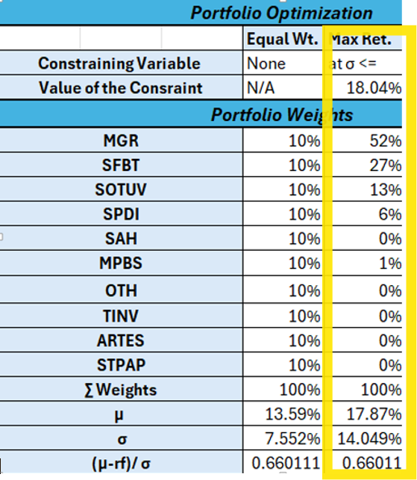
- Minimizing Standard Deviation:
As part of the portfolio optimization process through this method, we wanted to minimize risk while ensuring stable returns. However, focusing on volatility alone is not sufficient, as it does not account for how stocks interact with one another in a portfolio.
To truly understand the overall risk of the portfolio, we also needed to evaluate the correlation between the stocks, which shows how their returns move in relation to each other. Stocks with low correlations are particularly valuable for diversification, as their price movements tend to be independent, thereby helping reduce the overall risk of the portfolio. Next, we constructed the covariance matrix, which enabled us to assess the relationships between stock returns and their collective impact on the portfolio. The matrix provided a clearer picture of how different stocks' returns interact, allowing us to understand the potential risk reduction that diversification could offer. By including stocks with low covariance, we were able to enhance the portfolio’s diversification and mitigate risk.
Using this data, we could proceed to optimize the portfolio weights by minimizing overall portfolio volatility through modern portfolio theory. This method would allocate greater weight to stocks with lower standard deviations and minimal correlations with other stocks, helping to reduce the portfolio’s overall standard deviation and create a more stable investment profile. We also wanted that this portfolio’s return be at least 13.59%.
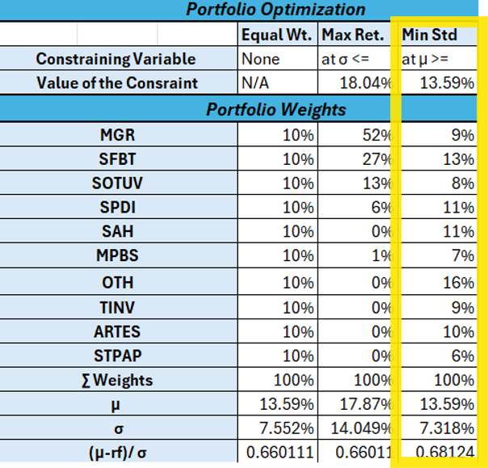
We obtained as a result of this method the following:

- Maximizing Sharpe Ratio:
To determine the optimal portfolio weights, our group followed a structured approach rooted in the Markowitz Model to plot the Efficient Market Frontier. We began by gathering historical return data for the selected stocks, which allowed us to compute their average returns and standard deviations (representing risk). Next, we calculated the covariance matrix, which helped us understand how the returns of the stocks interacted with one another. Using this data, we explored various portfolio combinations by adjusting stock weights to assess their risk-return profiles. Optimization techniques were then applied to either maximize returns for a given level of risk or minimize risk for a specific return. After these calculations, we plotted the Efficient Frontier, which visually displayed the optimal portfolios that strike the best balance between risk and return. To ensure our portfolio met the goal of maximizing risk-adjusted returns, we incorporated the Sharpe Ratio into the analysis. By seeking to maximize this ratio, we aligned our selections with the objective of achieving the highest possible return for the lowest amount of risk. This methodical, data-driven process provided us with the optimal portfolio weights that reflect both our risk preferences and investment goals.
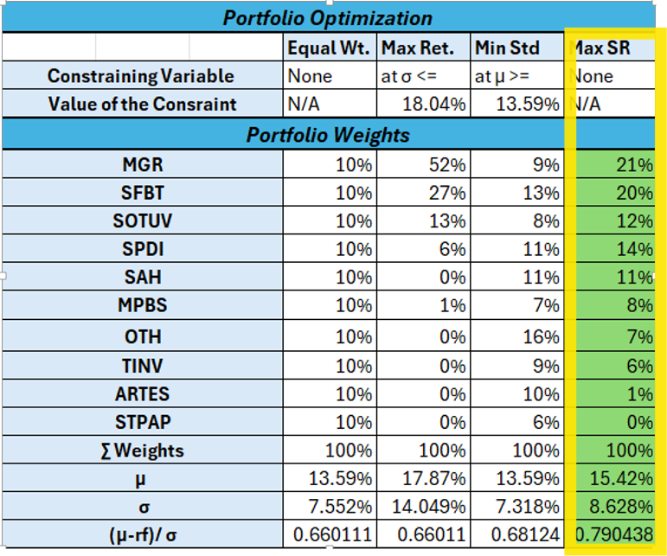
The Markowitz Model yielded an optimized portfolio of 9 stocks, excluding one stock due to its zero weight allocation and we obtained the following weight of the 10 stocks in the optimal portfolio as well as the Efficient Market Frontier:
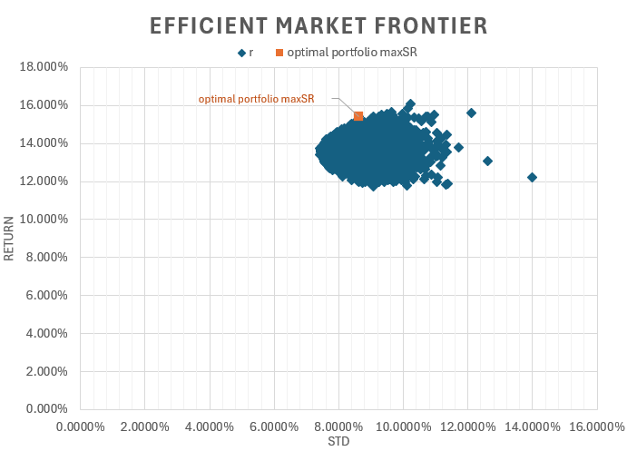
- Conclusion about the chosen method:
The first method, which focuses solely on maximizing return, overlooks the crucial aspect of risk, potentially leading to portfolios with high returns but significant volatility. The second method, aimed at minimizing risk, prioritizes stability, yet it may result in suboptimal returns, limiting the portfolio's potential for growth. In contrast, the third method—maximizing the Sharpe Ratio—offers a more balanced and comprehensive approach. By considering both return and risk, the Sharpe Ratio optimizes risk-adjusted returns, ensuring that the portfolio delivers the highest return for a given level of risk. Furthermore, this method inherently aligns with our risk-adjustment needs by balancing both risk and reward, making it an ideal fit for our conservative risk profile. As conservative investors, we prioritize stability and moderate returns, and maximizing the Sharpe Ratio allows us to achieve that balance. Therefore, this method is the most appropriate for selecting portfolio weights, as it ensures an optimal mix of risk and return while adhering to our conservative investment strategy.
PART 5: TECHNICAL ANALYSIS AND ENTRY POINT:
To determine the type of orders and entry points for our chosen stocks, we relied on a combination of technical analysis tools and time-sensitive execution strategies. Due to the time constraints of this project, all transactions were conducted using market orders, ensuring prompt execution on December 13, 2024. Our primary source of technical analysis was investing.com , which provided a comprehensive overview of trends, support, and resistance levels for the selected stocks. Additionally, we performed our own technical analysis using the Relative Strength Index (RSI) to identify potential overbought or oversold conditions. However, the RSI analysis was somewhat constrained by the dataset provided by the broker, which only extended to September 24, 2024, limiting the scope for more recent trend assessments. Despite these limitations, we combined the insights from both analyses to make informed decisions on entry points. For each stock, we provide a detailed rationale supported by technical charts that illustrate the indicators and patterns influencing our decisions.
- Société Frigorifique et Brasserie:
- Entry Price: 11.80 TND
- Number of Shares Bought: 5
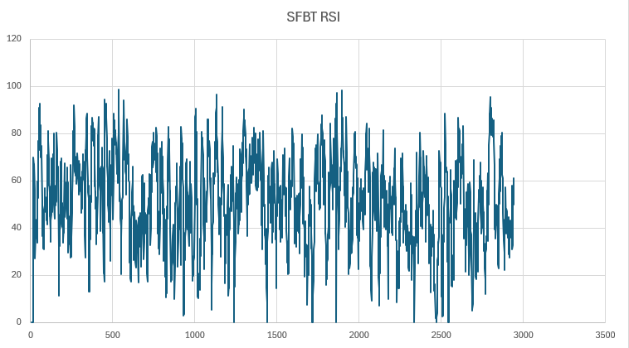
- Chart:
- Société d’Articles Hygiéniques:
- Entry Price: 10.07 TND
- Number of Shares Bought: 3
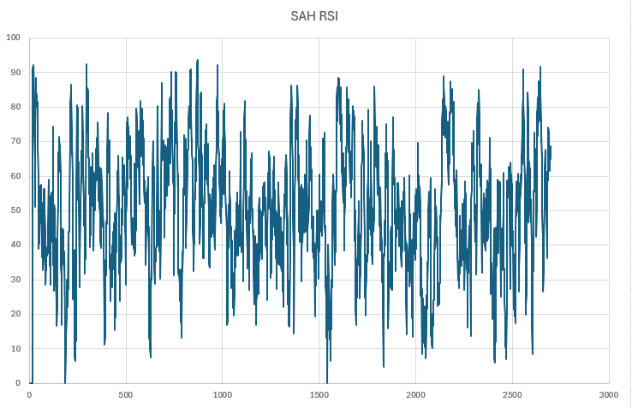
- Chart:
- Société Tunisienne des Marchés de Gros SA :
- Entry Price : 6.49 TND
- Number of Shares Bought: 9
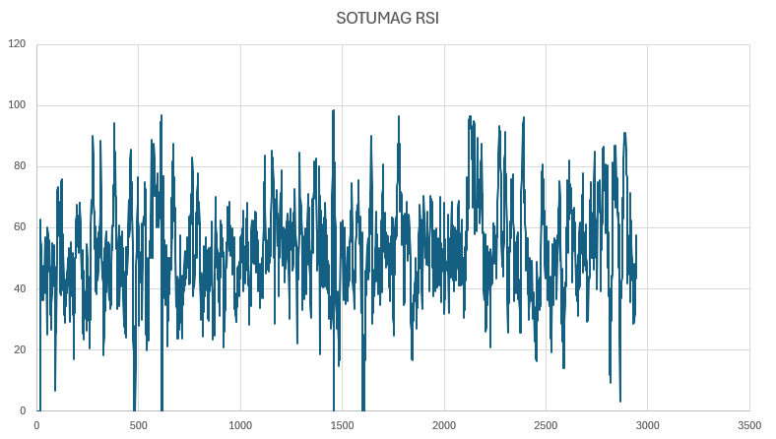
- Chart:
- Automobile Réseau Tunisien Et Service SA :
- Entry Price : 8.00 TND
- Number of Shares Bought: 1
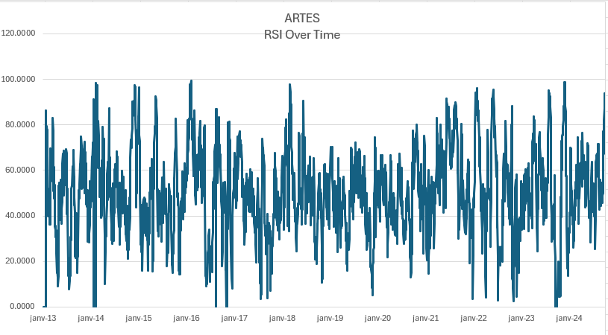
- Chart:
- Société Tunisienne De Verreries :
- Entry Price : 12.88 TND
- Number of Shares Bought: 3
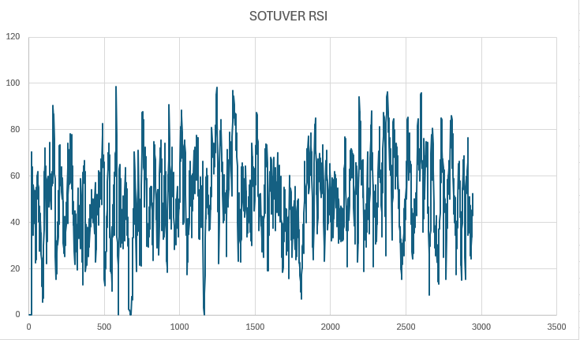
- Chart:
- One Tech Holding :
- Entry Price : 9.48 TND
- Number of Shares Bought: 1
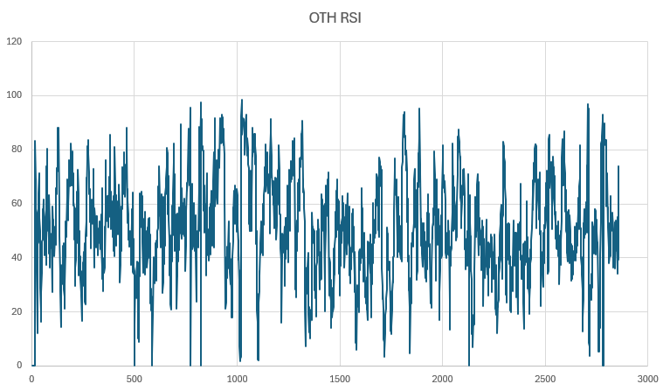
- Chart:
- Manufacture de Panneaux Bois du Sud SA :
- Entry Price : 11.88 TND
- Number of Shares Bought: 2
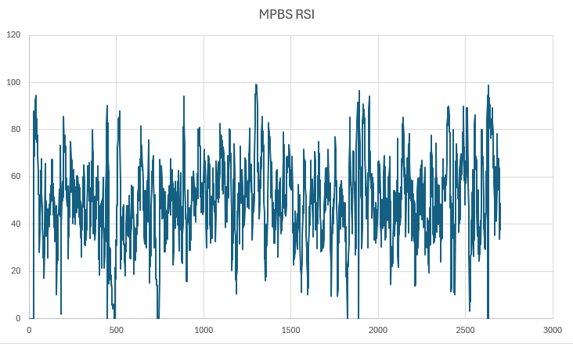
- Chart:
- SPDIT-SICAF :
- Entry Price : 10.94 TND
- Number of Shares Bought: 3
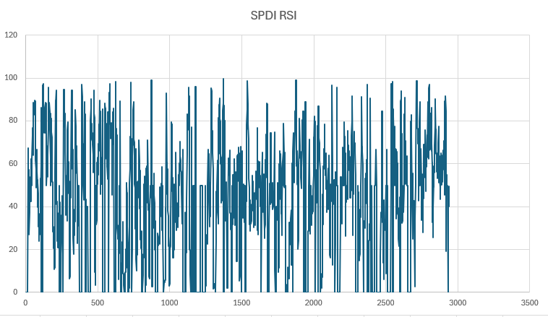
- Chart:
- TUN INVEST – SICAR :
- Entry Price : 9.25 TND
- Number of Shares Bought: 1
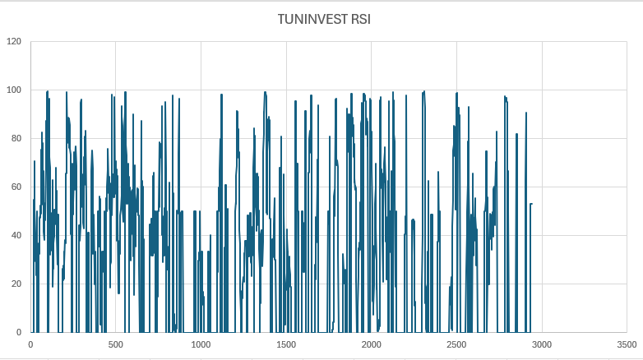
- Chart:

PART 6: PORTFOLIO REBALANCING:
In this section, we evaluated the portfolio for potential rebalancing during the short-term investment period from December 13, 2024, to December 31, 2024. Despite some stocks experiencing price declines, we chose to retain our initial holdings. This decision was driven by the limited timeframe of the investment, where rebalancing was deemed unnecessary due to the associated transaction costs and the potential for market volatility to correct in the remaining period. By holding the stocks, we aimed to maintain the portfolio's original structure and avoid premature adjustments that could compromise our short-term objectives.
PART 7: PERFORMANCE EVALUATION:
In this analysis, we tracked the performance of our portfolio from December 13 to December 31, 2024, starting with an initial balance of 280 TND, and concluding with a slightly higher balance of 280.3 TND, reflecting a total portfolio return of 0.12% over the period. The picture below shows the ending balance as of December 31, 2024:
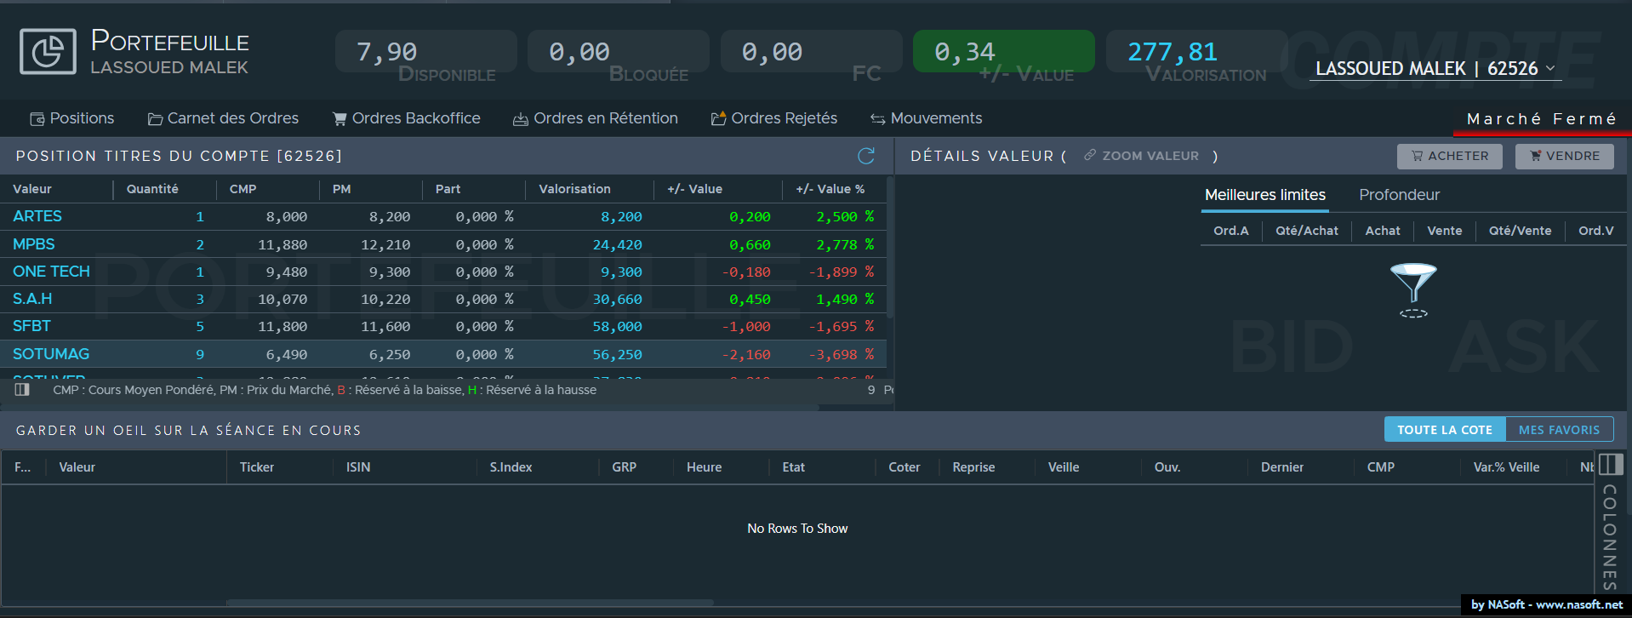
- Portfolio Composition:
The portfolio was diversified across various sectors, with the following distribution of investments:
- Consumer Goods: 13.79%
- Basic Materials: 20.69%
- Automotive Distribution: 17.24%
- Finance and Investment: 20.69%
- Manufacturing: 20.69%
- Food and Beverages: 6.9%
This diversification aimed to spread the risk across sectors, which can offer some protection against sector-specific downturns while capturing potential upside from various industry movements.
- Time-Weighted and Money-Weighted Analysis:
We performed both time-weighted analysis and money-weighted analysis to assess our portfolio's performance in a robust manner. The time-weighted return allowed us to evaluate the effect of the overall portfolio’s performance, while the money-weighted return took into account the impact of cash flows over time. The cumulative cash flows on December 31, 2024, amounted to 0.370 TND, showing a modest increase in funds over the analysis period.
- KPIs (Key Performance Indicators) :
To monitor the portfolio's performance on a daily basis, we tracked several important metrics. We provided the daily return of each stock and the daily return of the portfolio to ensure a transparent assessment. Additionally, we monitored the available amount to invest, helping us make adjustments in line with any changes in the portfolio value or opportunities in the market.
- KRIs (Key Risk Indicators) :
In terms of risk assessment, we calculated several important ratios to understand the risk profile of the portfolio:
- Sharpe Ratio: -1.04, indicating that the portfolio’s risk-adjusted return was negative, meaning that the return per unit of risk was not favorable.
- Sortino Ratio: -1.897, which is even more concerning as it accounts for downside volatility, highlighting that the portfolio experienced significant negative returns relative to the risk taken.
- Portfolio Beta: 0.118, suggesting that the portfolio was less volatile than the overall market, showing a relatively low level of market sensitivity.
- Cumulative Daily Returns of Stocks:
The cumulative daily returns from December 13 to December 31 varied significantly across the stocks in the portfolio:
- SAH: +1.49%
- SPDI: +9.69%
- SFBT: -1.69%
- SOTUVER: -1.48%
- SOTUMAG: -3.7%
- MPBS: +2.78%
- ARTES: +2.5%
- OTC : -1.89%
- TUNINVEST: 0%
These returns contributed to the overall portfolio's modest positive performance of 0.12%. The significant positive return from SPDI was the main contributor to the portfolio’s growth, while stocks like SFBT, SOTUVER, and SOTUMAG led to negative returns, dragging the overall performance down.
- Conclusion and Performance Evaluation :
In conclusion, while the portfolio achieved a modest positive return, the risk-adjusted metrics indicate that there are areas for improvement in terms of both returns and risk management. The Sharpe and Sortino ratios are notably negative, suggesting that the portfolio did not generate favorable returns relative to the risk it took. Moving forward, refining the strategy—perhaps by adjusting sector allocations or individual stock choices—would be crucial to improving performance.
For a more comprehensive view of the analysis, including charts and dashboards, please refer to the following link to access the full report: Daily Performance Analysis

